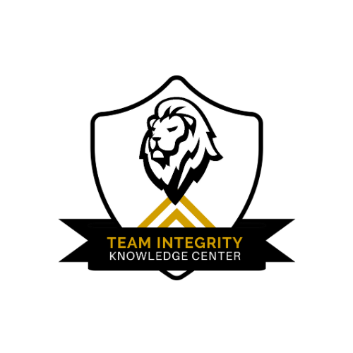
Virtual Visit Checklist

As a valued Team Integrity client, we understand the unknowns when it comes to certification and virtual visits. Preparing for a state certification virtual meeting involves several key steps to ensure you're ready to present your company's qualifications and meet the certification requirements. Here's a suggested approach:

1. **Environment**: Make sure to take the call in a quiet environment that is well-lit and preferably a home office on a desktop.

2. **Dress to Impress**: Dress professionally as you would for an in-person meeting. Your appearance should reflect your company's professionalism. Hint: wear a company shirt!

3. **Prepare Documentation**: Gather all necessary documentation, such as business licenses, tax returns, financial statements, and proof of ownership (if applicable). Just in case...

4. **Practice Your Pitch**: Prepare a brief, compelling pitch about your company, focusing on key strengths and qualifications. Practice delivering it confidently.

5. **Technology Check**: Test your internet connection, webcam, microphone, and any other technology you'll be using for the virtual meeting. Ensure everything works smoothly.

6. **Prepare Questions**: Prepare questions to ask during the meeting to clarify any questions and inquire about the next steps.

8. **Be Punctual**: Log in to the virtual meeting platform a few minutes early to ensure you're ready when the meeting starts.

9. **Follow-Up**: After the meeting, follow up with any additional information or documentation requested by the certification board.

10. **Stay Informed**: Stay informed about any updates or changes to the certification process or requirements.

***THE #1 thing to remember is who is leading as 51% or more shareholders should be present for the meeting. For example, if you are going for women-owned certification the woman must be present.

By following these steps, you can effectively prepare for your state certification virtual meeting and increase your chances of success.

Good Luck and Tell us how it went
#Team Integrity

